FISMATIC

Test and Evaluation Management Plan

Version 1

May 19, 2020

This document was developed using version 2.1 (released March 2016) of the Test and Evaluation Plan template.  Printed copies of this document may not contain the most recent updates.

Document Revision History

| **Version** | **Publication Date** | **Revision Description** | **Section** | **Author** |
| --- | --- | --- | --- | --- |
| 0.1 | 5/6/2020 | Initial | All sections of document | Stacie Whitesides |
| 0.5 | 5/13/2020 | Updated and addressed all comments and points feedback | All sections of document | Stacie Whitesides |
| 1.0 | 5/14/2020 | Updated and addressed all comments and points feedback | All sections of document | Stacie Whitesides |

Table of Contents

1 Document Overview 1

1.1 1

1.2 1

2 PoC Pilot Test Strategy 2

2.1 PoC Pilot Testing Lifecycle 3

2.2 Test Personnel 4

2.3 Download Requirements and Test Instructions 4

2.5 Severity Level 6

2.6 Type of Data Used 6

2.7 PoC Pilot Test Model Evaluation 6

3 Points of Contact 8

Appendix A Acronyms 9

# Document Overview

1.1 Purpose

The Test and Evaluation Management Plan (TEMP) is the strategy that outlines and tracks important tasks and procedures associated with testing and evaluation of the Federal Information Systems Management Assessment Tool for Intelligent Compliance (FISMATIC) tool proof of concept (PoC) throughout the testing phase.

1.2 Scope

FISMATIC is a proof of concept (POC) that is currently being developed by the Census Bureau Center for Applied Technology (CAT). This is a machine learning PoC that sets out to assist and streamline the bureau’s Authority to Operate (ATO) with natural language processing. FISMATIC seeks to demonstrate improvements to certifying the security and compliance of bureau information systems by reducing costs, speeding time to completion, and improving consistency. This TEMP outlines the process by which the CAT PoC team will conduct pilot testing.

# 2 PoC Pilot Test Strategy

The PoC team is currently conducting pilot testing across various users groups. The PoC pilot testing is an important activity necessary to verify POC design assumptions and identify priorities for future capability development. Pilot users have been identified based on knowledge of the ATO process, experience with Office of Information Security (OIS) processes, and National Institute of Standards and Technology (NIST) Special Publication (SP) 800-53.

The focus of the FISMATIC pilot testing are the following capabilities:

* Development of User Responses
  + Allows the user(s) to edit responses or enter their own response
  + Gives test step definition and status
  + Enables user to save response and continue with next step
* File Upload
  + The user is able to upload CSV file on the front end of FISMATIC

The three figures below illustrate what the test users will see once launching FISMATIC.

Figure 1: Navigation Page

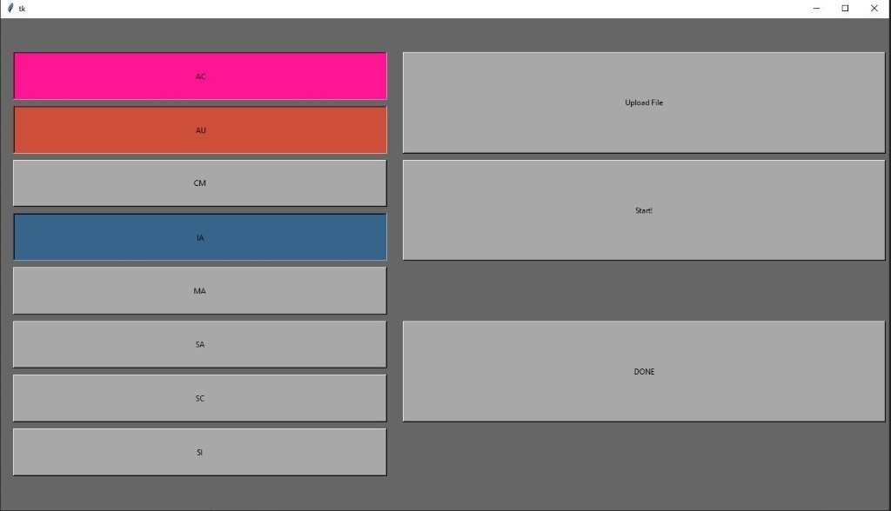

Figure 2: Control Response Page

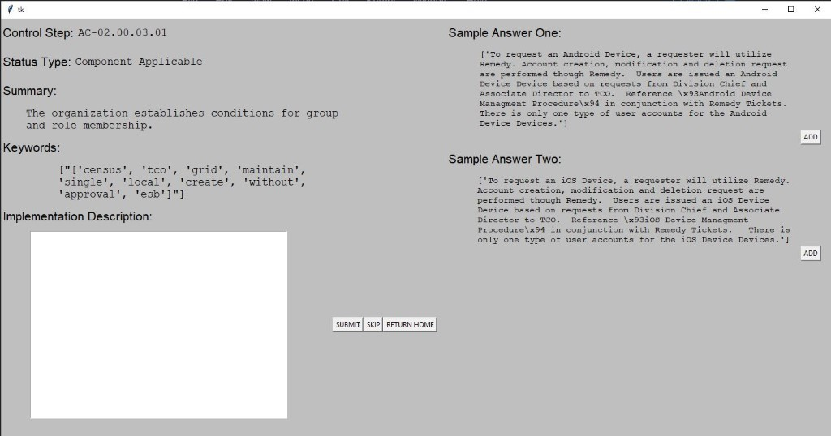

Figure 3: File Upload Key

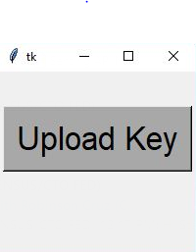

## 2.1 PoC Pilot Testing Lifecycle

The PoC pilot test is currently being conducted in an iterative agile iterative. After the PoC team has identified the test users, they are then sent test instructions to begin testing. Pilot testing for the PoC is conducted in two week increments.

Table 1: Test Schedule

| **Testing Type** | **Scope of Testing** | **Number of Testers** | **Testing Schedule** |
| --- | --- | --- | --- |
| Pilot Testing | Pilot test against the capabilities of the tool | 2-4 | Two week rotational test |

## 2.2 Test Personnel

Pilot testing is being conducted by bureau system owners and assessor teams with experience executing successful Authority to Operate (ATOs).

## 2.3 Download Requirements and Test Instructions

**Download Requirements:**

1. A Census-Issued computer (Desktop or Laptop). The data is sensitive, so it must stay on Census workstations.
2. Download and Set up Secret Agent. This is required to receive the download file for FISMATIC. The zip file will contain sensitive ATO data, thus must be transferred using Census approved file transfers system. For instructions, please follow this directions, here: <https://collab.ecm.census.gov/div/ltso/intranet/Documents/SecretAgentVersion6.2.4UserGuide.pdf>

**Note**: If you run into a “certificate note found” error, make a remedy request for a new Secret Agent certificate. Open Remedy> Network>User Certificates>Request Now click “Add” & Type is “Secret Agent/DBSIGN”, if this doesn’t work try calling IT.

1. Anaconda Navigator- This is the Census approved download to get Python 3 installed on your machine. You can download this through the Census mirror here: Please Note: If you have installed Anaconda before, do not click this link unless Anaconda has been fully uninstalled from your Census machine.

**For a windows PC**: http://mirror1.csvd.census.gov/python/repo.continuum.io/archive/Anaconda3-2019.10-Windows-x86_64.exe

**Initial Download of FISMATIC:**

1. Once all three requirements have been met, email Stacie Whitesides (stacie.whitesides@census.gov) and Sarah Crumling (sarah.g.crumling@census.gov) to let us know and we will email an encrypted zip file (to be unencrypted with Secret Agent) followed by another encrypted file contacting the key.key file.
2. You will receive two emails from Sarah or Stacie with the encrypted files. Follow the directions for Secret Agent linked above (in Step 2) for how to decrypt the files. Make sure to download the files directly onto your Census machine (either into Desktop or Documents folder), NOT a shared drive. The dataset FISMATIC uses is currently sensitive data. Remember where you save the ‘key.key’ file.
3. Once downloaded and decrypted, unzip the FISMATIC file (it should prompt you to do this after download, or if you double-click the zip file)
4. Once unzipped, locate the “run_FISMATIC” file and double click it.
5. Your command prompt should pop up, and will prompt you to download spaCy (a python package). If it prompts you to continue (y/n) type “y” and hit enter.
6. It may take several minutes while the download completes- this should only happen on the very first time you open the file. After the download, wait a few minutes for the FISMATIC file to run.
7. A window should pop up, prompting you to upload a key. Click ‘Upload Key’ to select the ‘key.key’ file that you decrypted with Secret Agent. Uploading the correct key will have the program continue.
8. After the key is verified, a window should pop up with the Navigation Page- if you don’t see it, check your menu bar at the bottom of your screen for an application with a blank page icon, sometimes it doesn’t pop up to the front on the first time.
9. Run through a control family- adding sample responses, typing your own and testing the ‘SKIP’ and ‘SAVE’ buttons to make sure it runs through without errors. When you are done simply exit out with the ‘X’ in the top right.
10. You’re done! If you’ve reached this point, FISMATIC is successfully installed and you can move on to the next set of instructions! To run FISMATIC again at any point, you just double click “run_FISMATIC” and it should open up without issue. Otherwise, if you run into any issues- email to the PoC team at cat@census.govto let us know and we will help get it sorted out.

**Preparing your own documentation:**

FISMATIC runs based off a spreadsheet that you provide. This spreadsheet should be available to download from Risk Management Program System (RMPS), however it’s a fairly simple spreadsheet to create if any issues occur. The required columns are:

1. **“ctrl_step”** The Control Step: In the Format XX-00.00.00.00 (ex: AC-02.00.01.01)

2. **“procedure_txt**”: The definition of the control step

3. **“status_type”**: Notes if the control is ‘Component Applicable’, ‘Not Applicable’, ‘Tailored’ or ‘Hybrid’

Column titles should make these exactly; however, extra columns can be added and will not be impacted. Note: Even when downloaded from RMPS, the column headers of these 3 columns will need to be changed and saved as a CSV file)

These column headers and entry formats are very specific, as the code reads them in a particular way to display the information. See the ‘Sample_ATO.csv’ file for an example of how the file should look. Again, any additional columns in your excel files is fine- the program will leave these alone, and simply add a new column containing your responses and save as a separate file. Make sure it is saved as a .CSV file.

Preparing documentation is a tedious and time-consuming step that will not have to happen in the future. Unfortunately, key features need evaluation before the program can be further fine-tuned. If this part is causing issues, please do not hesitate to reach out to and Sarah Crumling (sarah.g.crumling@census.gov) for assistance in formatting your files and pull any needed information. We appreciate the time and effort you’ve taken to help us improve our product design and features.

**Running FISMATIC the Second Time:**

Now that you have done your initial run to download the programs/ensure the download went smoothly and prepared your file correctly you are ready to run FISMATIC on your own.

1. Double-Click “run_FISMATIC”

2. Upload your key.key file

3. Once you see the navigation page, click ‘Upload File’ and select your own CSV file (formatted as described above). It may take a minute or two for the program to read in your file and update.

4. The Navigation Page should show a button for all Control Family’s represented in your file- Select which one you would like to start with and click ‘Start’

5. The program will run through each control step inside the family (that is Applicable), showing two sample responses you can use, and work from or ignore and write your own response.

6. Once you are satisfied with your response hit ‘Submit’. If you do not want to provide a response to an answer, simply click ‘Skip’. If you want to come back to the set of control families later, you can click ‘RETURN HOME’ and the program will record your progress. Note: If you have already run through the entire control family previously, hitting ‘Submit” will overwrite your previous answer, be careful if running through the same control family twice.

7. Once you have run through all the control families and are done providing the responses you want, click ‘DONE’ to export your spreadsheet and exit the program. Note you MUST hit ‘DONE’ to export the spreadsheet, or your information will be lost.

**A Few Notes:**

Your finished file will export as “FISMATIC_MM_DD_YYYY_HH_MM.csv” (aka ‘FISMATIC_DATE_TIME.csv’) once you hit ‘DONE’. It will save to the same location as the rest of the FISMATIC files.

Anytime you run into an issue, or find something not straightforward, take note! These are types of things we are looking to improve! While we have a list of some glaring issues (like having to format your excel documents by hand), you have a different perspective and might find issues we haven’t thought about. Also, any additions you think would improve the program.

Feel free to reach out to the PoC team at cat@census.gov at any point with questions or concerns. We are available to help you at any point in your testing.

## 2.5 Severity Level

There will be no severity level for test the PoC.

## 2.6 Type of Data Used

The data used for the FISMATIC PoC is sensitive ATO data that is downloaded from the Risk Management Program System (RMPS). The download from RMPS is a CSV file that is then cleaned and modified before being loaded into FISMATIC. The tool then organizes the control steps and provides step by step recommendations based on successful ATO’s and user input. FISMATIC is a Python program and the interface is a Tkinter GUI. The backend reads the CSV file uploaded by the test users which is downloaded directly from RMPS for each applicable control step.

## 2.7 PoC Pilot Test Model Evaluation

The PoC pilot test model evaluation will enable end users to evaluate real-world scenarios to test the FISMATIC tool before it is deployed. Testing scenarios may include:

* **User Scenarios Testing**—Evaluates the user interface and the quality of the responses presented by the model, use of the output, and provide feedback.
* **Business Process Testing**—Evaluates the system based on real-world business processes and workflows

**Figure 4: FISMATIC PoC Test Process**

# 3 Points of Contact

| **Role** | **Responsibility** | **Name** | **Organization** | **Phone** | **Email** |
| --- | --- | --- | --- | --- | --- |
| Project Manager & Project Owner | Ensure system developed and available for testers | Robinson Cruz | CTO | 301-763-2053 | Robinson.Cruz@census.gov |

# Appendix A Acronyms

| **Acronym** | **Definition** |
| --- | --- |
| AC | Account Management |
| AI | Artiﬁcial Intelligence |
| AU | Auditing Requirements |
| CIO | Chief Information Officer |
| CM | Configuration Management |
| CSV | Common-separate Value |
| FISMATIC | Federal Information Systems Management Assessment Tool for Intelligent Compliance |
| IA | Identification and Authentication |
| ISSO | Information System Security Officer |
| NIST | National Institute of Standards and Technology |
| OIS | Office of Information Security |
| PIK | Protected Identification Key |
| PoC | Proof of Concept |
| RMPS | Risk Management Program System |
| SC | Plan System and Communications Protection |
| SI | System and Information Integrity |
| SP | Special Publication |
| TEMP | Test and Evaluation Management |